Power Shell 101

**Module 1B – PowerShell in VSCode**

3/2/2019 Developed by Sam Chung

10/03/2020 Revised by Kim Nguyen

Center for Information Assurance (CIAE) @City University of Seattle (CityU)

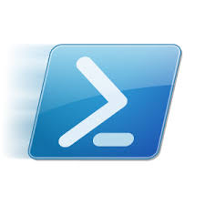

**Learning Outcomes**

* Learn how to install the PowerShell extension in VSCode

**Resources**

* PowerShell in Visual Studio Code, <https://code.visualstudio.com/docs/languages/powershell>

**Activities**

* Installing
* Testing
* Q&A

**Installing**

1. Open your VSCode.  
   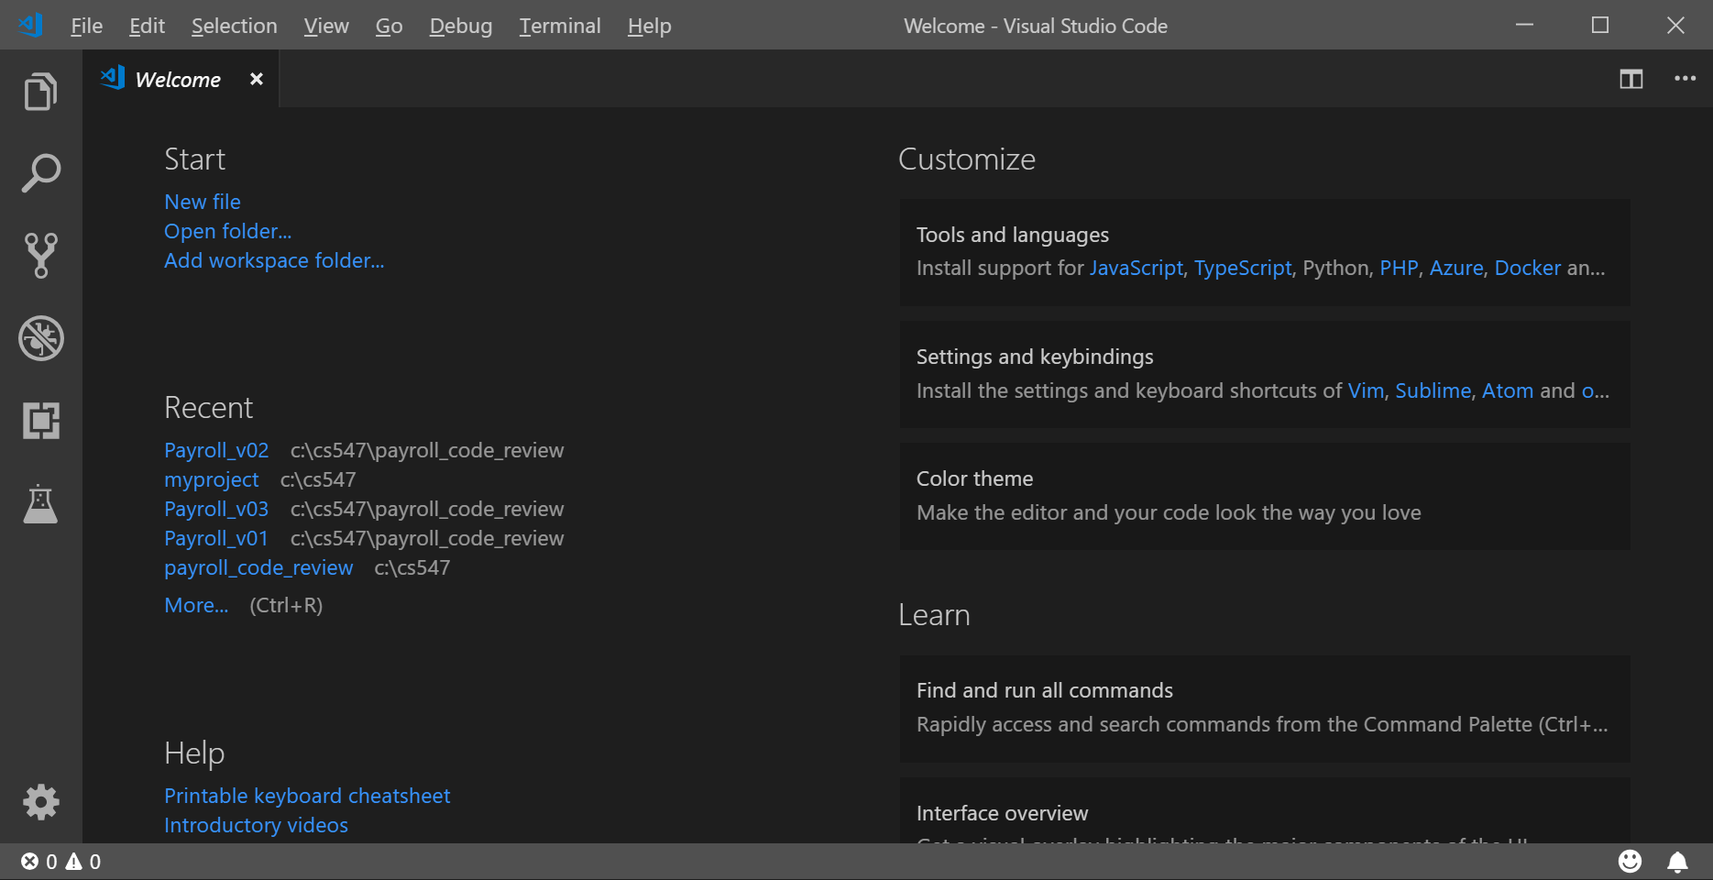
2. Open the Extensions view with keyboard shortcut “Ctrl+Shift+X” and typing “PowerShell” and select the PowerShell extension.  
   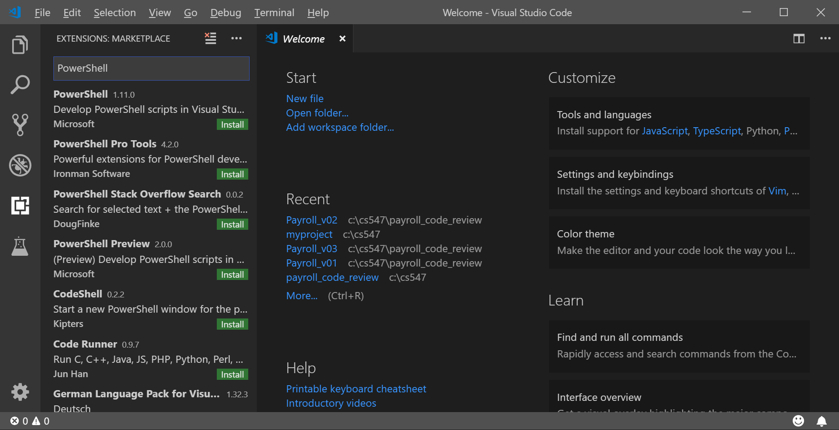
3. Install “PowerShell”

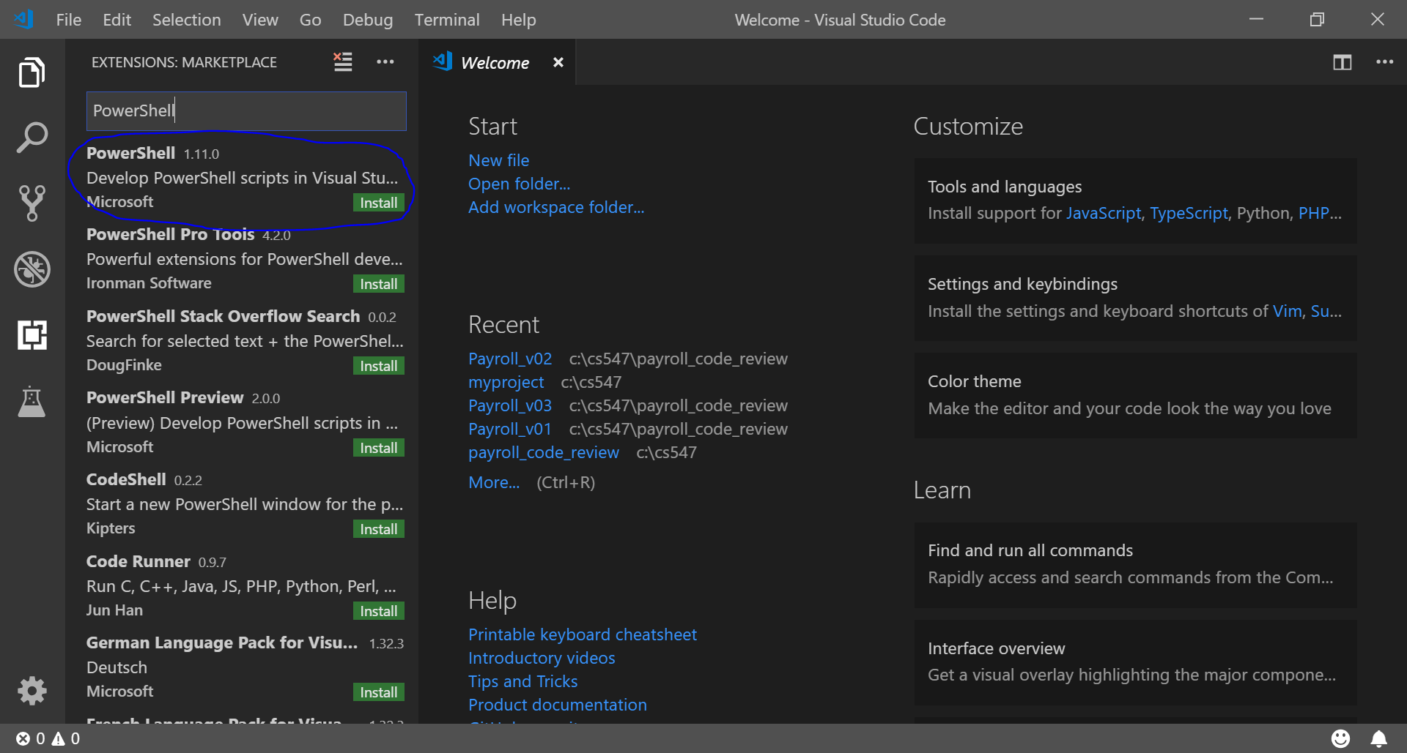

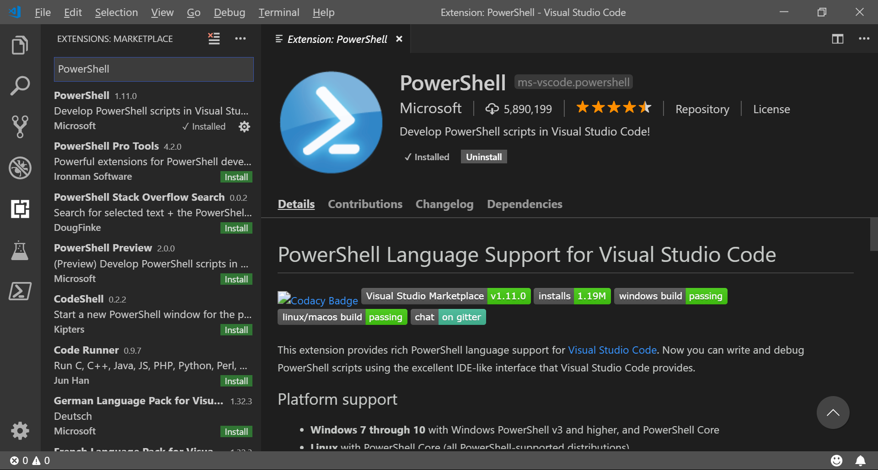

**Testing**

1. To determine what version of PowerShell you have, type “$PSVersionTable.PSVersion”  
   You can see a little table with four columns: Major, Minor, Build, and Revision.

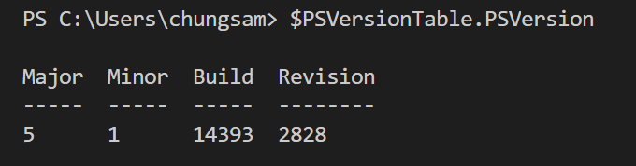

1. When you forget PowerShell syntax or want to learn how a command work, if you type “Show-Command *command*” you can see that a GUI dialog box will be opened to help you complete a command. For example, type “Show-Command Get-EventLog”  
   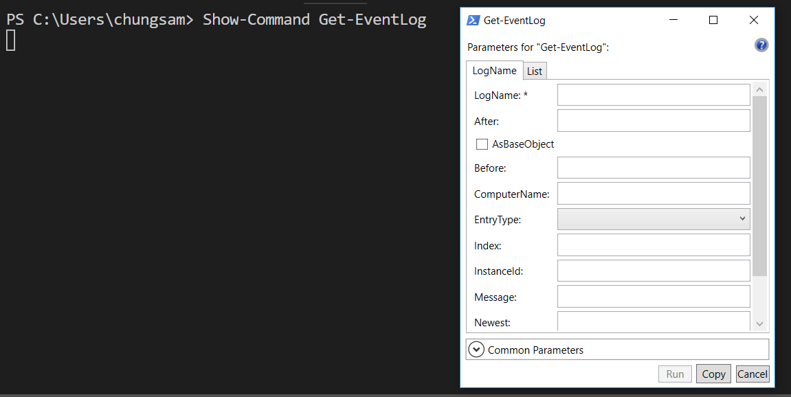
2. To know your current directory, type “Get-Location”  
   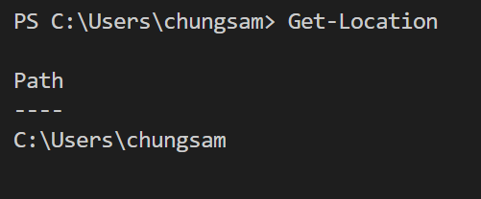
3. To know your current directory, type “get-location” and “gl”  
   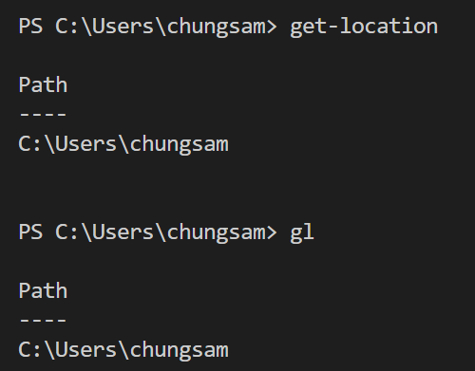

**Q&A**  
Justify your answers with at least one reference.

1. What is PowerShell?

1. Why do you need to learn PowerShell